NETWORK ESSENTIALS / CCNA COURSE INTRODUCTION
About The Instructor –
About the course-
Course Prerequisites – NA
INTRODUCTION
Topic syllabus discussion.
Network
Two or more devices connected to each other and sharing its information and resources.

ARP
The Address Resolution Protocol is a communication protocol used to find MAC address using an IPv4 address.
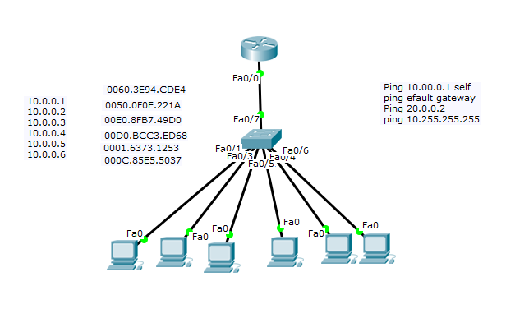
Arp –a , Arp –d ,Show mac address table .

ARP, Reverse ARP(RARP), Inverse ARP (InARP), Proxy ARP and Gratuitous ARP
we will discuss about whole ARP-family, which are ARP, RARP, InARP, Proxy ARP and Gratuitous ARP. Let’s try to understand each one by one.

1. Address Resolution Protocol (ARP) –
Address Resolution Protocol is a communication protocol used for discovering physical address associated with given network address. Typically, ARP is a network layer to data link layer mapping process, which is used to discover MAC address for given Internet Protocol Address.
In order to send the data to destination, having IP address is necessary but not sufficient; we also need the physical address of the destination machine. ARP is used to get the physical address (MAC address) of destination machine.
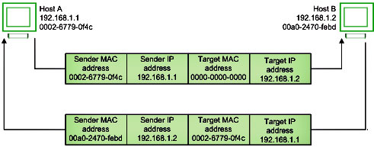
Before sending the IP packet, the MAC address of destination must be known. If not so, then sender broadcasts the ARP-discovery packet requesting the MAC address of intended destination. Since ARP-discovery is broadcast, every host inside that network will get this message but the packet will be discarded by everyone except that intended receiver host whose IP is associated. Now, this receiver will send a unicast packet with its MAC address (ARP-reply) to the sender of ARP-discovery packet. After the original sender receives the ARP-reply, it updates ARP-cache and start sending unicast message to the destination.
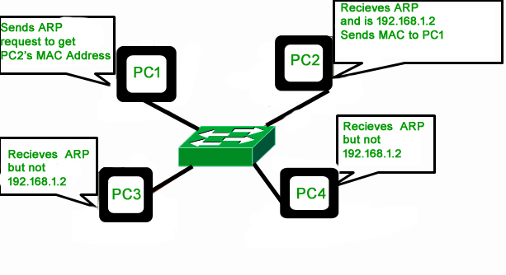

Common network types
PAN – Personal area network . Set of end devices connected to each other within 2 – 3 meter s

1. Personal Area Network (PAN)
PAN is the most basic type of computer network. This network is restrained to a single person, that is, communication between the computer devices is centered only on an individual’s workspace. PAN offers a network range of 1 to 100 meters from person to device providing communication. Its transmission speed is very high with very easy maintenance and very low cost.

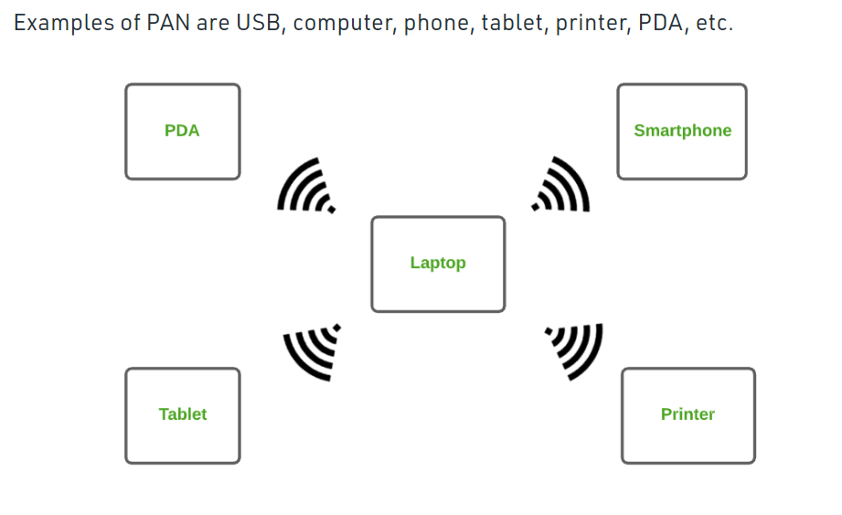

LAN – Set of devices connected with the same location

Local Area Network (LAN)

LAN is the most frequently used network. A LAN is a computer network that connects computers through a common communication path, contained within a limited area, that is, locally. A LAN encompasses two or more computers connected over a server. The two important technologies involved in this network are Ethernet and Wi-fi. It ranges up to 2km & transmission speed is very high with easy maintenance and low cost.
Examples of LAN are networking in a home, school, library, laboratory, college, office, etc.
WAN – 2 or more LAN outside the city limits

Wide Area Network (WAN)
WAN is a type of computer network that connects computers over a large geographical distance through a shared communication path. It is not restrained to a single location but extends over many locations. WAN can also be defined as a group of local area networks that communicate with each other with a range above 50km.
Here we use Leased-Line & Dial-up technology. Its transmission speed is very low and it comes with very high maintenance and very high cost.

NETWORK DEVICES
1.hub
2.Switch – Modular switch / Non modular switch , L2 switch L3 switch .
3.Router -- router is hardware device designed to receive, analyze and move incoming packets to another network.
4.Firewall – it’s a device that protects network form unauthorized access , controls incoming and outgoing traffic based on set of rules
5.Wireless access point – is a device that allows other Wi-Fi devices to connect to a wired network
6.WLC – Device which controls AP .

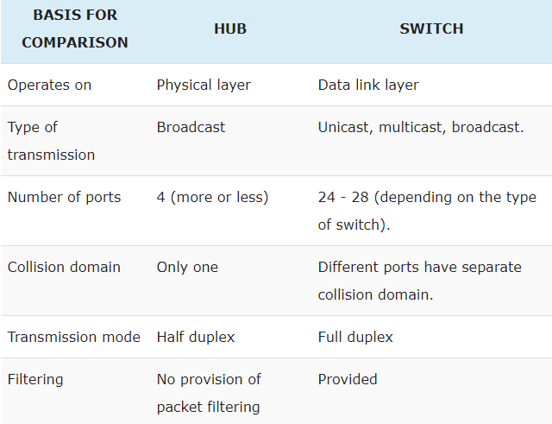

Transmission Modes.
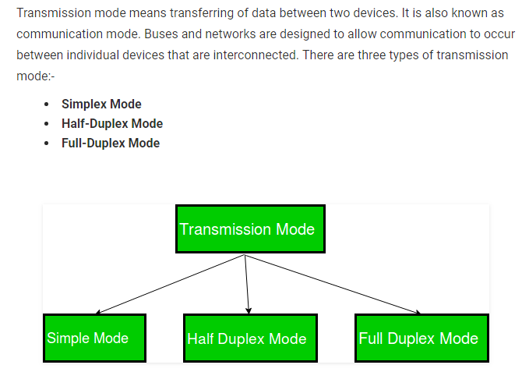

Simplex – One direction – Keyboard
Half duplex – Either send or receive , Walkie- talkie in which message is sent one at a time and messages are sent in both the directions.
Full Duplex – Telephone.

Diagramatical representations .
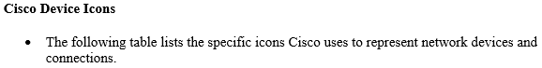
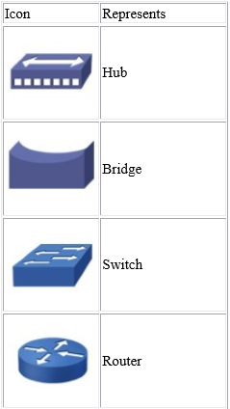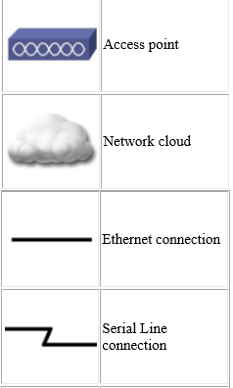
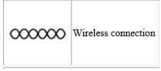

Types of cables
Types of cables
- Coaxial cable – Used for cable connections

- Twisted pair cable Twisted-pair cable is a type of cabling that is used for telephone communications and most modern Ethernet networks. A pair of wires forms a circuit that can transmit data. The pairs are twisted to provide protection against crosstalk, the noise generated by adjacent pairs.

Types of Ethernet cables .1 . Straight through , 2 . Cross over . 3 Rolled over

- Fiber optic cable - They're designed for long distance, high-performance datanetworking, and telecommunications. Compared to wiredcables, fiber optic cables provide higher bandwidth and can transmit data over longer distances.

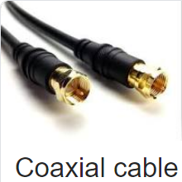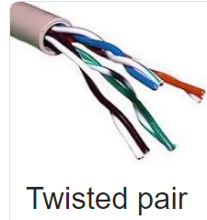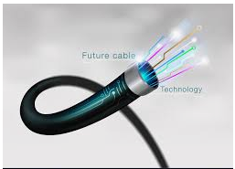
Ethernet : A system for connecting a number of computer systems to form a local area network, with protocols to control the passing of information and to avoid simultaneous transmission by two or more systems

Types of Ethernet cables .1 . Straight through , 2 . Cross over . 3 Rolled over

Color coding of cables
T-568A + T568A – Straight through cable
T-568B + T568B - Straight through able
T-568A + T568B – cross over cable

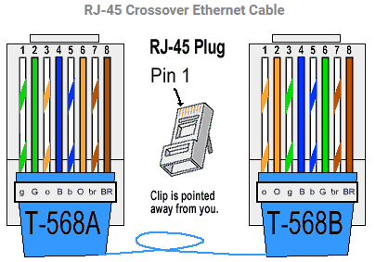

NOT SOO IMPORTANT……………………start
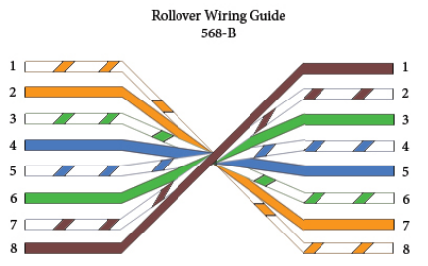

RJ45 and RJ11 – Connectors

NOT SOO IMPORTANT……………………start
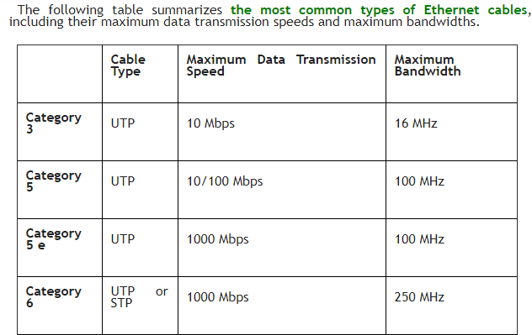
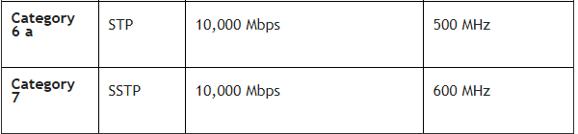

NOT SOO IMPORTANT……………………END

CISCO
CISCO SYSTEMS INC. IS THE WORLDWIDE LEADER in networking for the Internet. The company was founded in 1984 by two computer scientists from Stanford University seeking an easier way to connect different types of computer systems.
Cisco Systems shipped its first product in 1986 and is now a multi-national corporation, with over 35,000 employees in more than 115 countries. Today, Cisco solutions are the networking foundations for service providers, small to medium business and enterprise customers which includes corporations, government agencies, utilities and educational institution

Communication between hosts can be classified into three types:
- Unicast – Communication from one host to another host only.
- Broadcast – Communication from one host to all the hosts in the network.
- Multicast – Communication from one host to few hosts only.
CD – How many devices can communicate at a time
BD – How far a Packet travels when a broadcast is done .

- Figure 1-3 A switched network
- 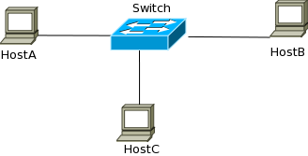
- Figure 1-4 Collision Domains – 1
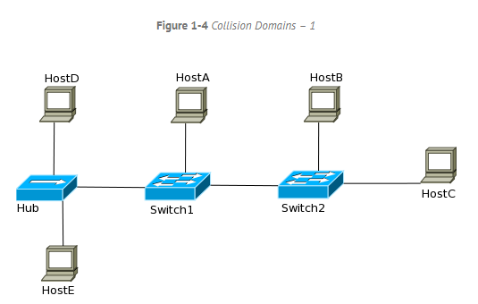
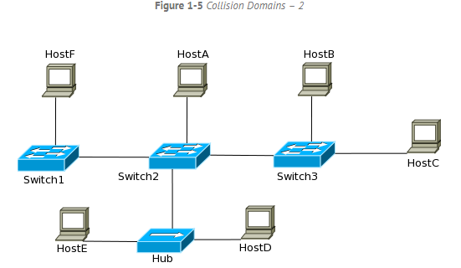
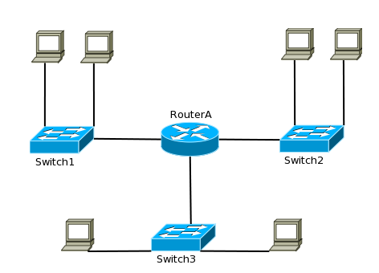

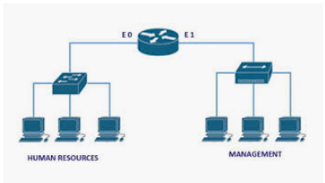

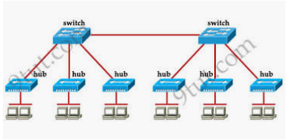
Switches break collision domains and routers break broadcast domains

SYLLABUS STARTS… IMPORTANT
OSI Layers / Host to Host communication model.
1.OSI 7 Layers and its Functionalities
2.OSI Layers and TCP Suite .

OSI MODEL AND TCP / IP MODEL.

DEFINETION: OSI / TCP-IP - model tells how the communication happens between two or more networking devices - within the organization or in the internet.

Each layer defines a set of functions in data communications.
OSI Model is a reference model which was developed by ISO which consists of 7 layers
We use OSI only as a reference ,
But when we talk about the TCP/IP model, it was designed and developed by Department of Defense (DoD) it has 4 layers . (practically we use TCP/IP model Theoretically for a reference we use OSI model ) .
NOTE : INTERNET works on TCP/IP model.

OSI Layers. There are 7 Layers.
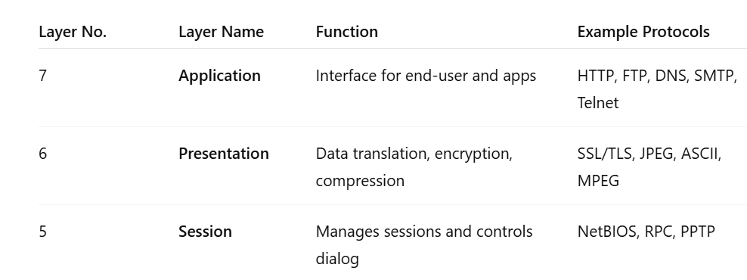
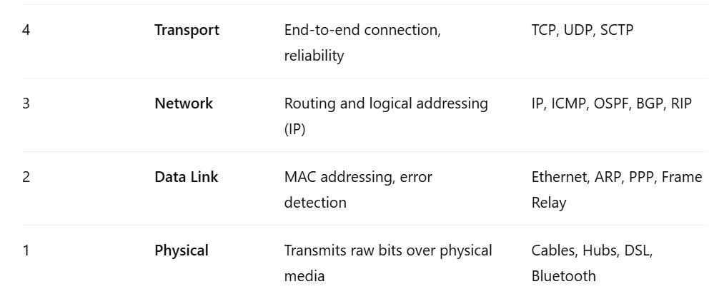

APPLICATION LAYER. Layer 7

The Application Layer is the 7th layer in the OSI (Open Systems Interconnection) model It Provides user interface for the users to interact with application services or Network services.

Example - Google Chrome, Putty , whats app etc.

PRESENTATION LAYER - 6

The Presentation Layer is the 6th layer in the OSI (Open Systems Interconnection) model
It is responsible for defining a standard format for the data.
.jpeg, .Doc, Zip files.

PDU – the data is in which form is called PDU – user data
PDU in presentation layer – Formatted data

SESSION LAYER – 5

The Session Layer is the 5th layer in the OSI (Open Systems Interconnection) model
It is responsible for Establishing, maintaining and terminating sessions.
It deals with interactions between the applications,
Session ID s are used to identify a session

You can use the list of sessions created in cmd prompt using NETSTAT command

Here comes the real networking part .

TRANSPORT LAYER

The Transport Layer is the 4th layer in the OSI (Open Systems Interconnection) model, responsible for end-to-end communication and data delivery between devices across a network –(def is imp don’t get confused with Def of DATA link layer)
Identifying the service and adding port number.

PORT NUMBERs
A port number is a logical number within a device that helps identify specific applications or services running on it. It works with IP addresses to make sure data reaches the correct program.

: Each and every service is identified using a port number
All protocols that comes under software layers will have port numbers but not protocol numbers.
Protocols that come under transport layer and below will have protocol numbers but not port numbers.
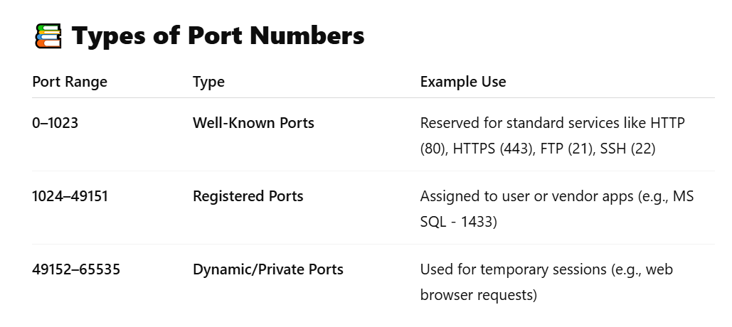
Functionalities of Transport Layer

Segmantation
Sequencing and Reassembling
Multiplexing and de multiplexing
Identifying the service
Flow control
Error correction

Data coming from session layer , will be divided in to chunks these chunks are called as segments , the size of the chunks is called MSS maximum segment size by default it is 1500 bytes.

There are 2 types of header , TCP header and UDP Header .
Transport layer decides whether the data has to be sent reliably [TCP – connection oriented ] or non-reliably [UDP Connectionless ],

Reliable - TCP
Seq 1 ---
----<<< ack 2
Seq 2 -
If ack not coming then again
Seq 2 - will be sent .

Unreliable – UDP – Continuous flow of traffic without any ack.
In UDP seq 1-
Seq 2 --
Seq 3 -
No ack just sending continuous data . If data is lost in the middle its lost forever , Now the question is who wants to loose the data ,
ANS : UDP will be used , when the time is imp than the DATA itself .
TCP is used when DATA is imp that time .

Before sending data a connection will be established called ,
3 way handshake
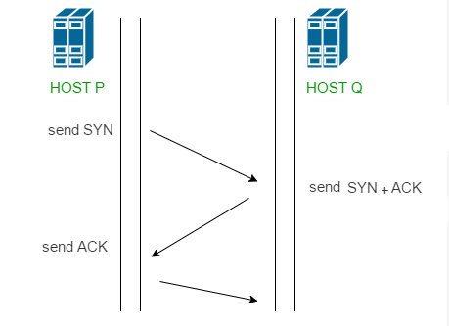
after which traffic will start flowing.

TCP protocols
UDP protocols
Almost all the protocols comes under TCP / UDP

Here's a clear breakdown of which common application-layer protocols using TCP or UDP as their transport protocol.

Protocols That Use TCP
These protocols require reliable, connection-oriented communication:
Protocol | Port | Description
HTTP | 80 | Web browsing
HTTPS | 443 | Secure web browsing
FTP | 21 | File Transfer Protocol
SFTP | 22 | Secure FTP over SSH
SMTP | 25 | Sending email
POP3 | 110 | Retrieving email
IMAP | 143 | Email access (more advanced than POP3)
SSH | 22 | Secure remote login
Telnet | 23 | Remote terminal access (insecure)

Protocols That Use UDP
These are used when speed is more important than reliability:
Protocol | Port | Description
DNS | 53 | Resolving domain names (can also use TCP for large queries)
DHCP | 67/68 | Dynamic IP assignment
TFTP | 69 | Simple, lightweight file transfer
SNMP | 161 | Network management protocol
RIP | 520 | Routing Information Protocol
NTP | 123 | Time synchronization
VoIP | Varies | Used for voice calls (e.g., SIP uses UDP 5060)
Syslog | 514 | Logging from network devices
mDNS | 5353 | Local network name resolution
BOOTP | 67/68 | Bootstrap Protocol (older version of DHCP)

but
There are some other protocols which neither uses TCP or UPD ,

Question : Is there any protocol that doesn’t use TCP and UDP ???? Yes
Ex: EIGRP or OSPF has its own protocols

Only TCP and UDP uses port number, Port number is a 16 bit number used by protocols that either uses TCP or UDP .

for ex HTTP : 80 HTTPS 443

Question What is the port number of EIGRP and OSPF .
There are no port numbers for the above two .

…..

PDU (Protocol Data Unit) of Each OSI Layer
In networking, a PDU (Protocol Data Unit) is the name given to data at each layer of the OSI model. It changes as data moves through the layers during transmission.
OSI Layer No. | Layer Name | PDU Name | Description
7 | Application Layer | Data | User-generated data (e.g., message, file)
6 | Presentation Layer | Data | Data formatting, encryption, compression
5 | Session Layer | Data | Session control data
4 | Transport Layer | Segment | Adds TCP/UDP headers, port info
3 | Network Layer | Packet | Adds logical addressing (IP headers)
2 | Data Link Layer | Frame | Adds MAC addresses, error checking
1 | Physical Layer | Bits | Transmits raw bits (0s and 1s) over cable

Header Sizes.
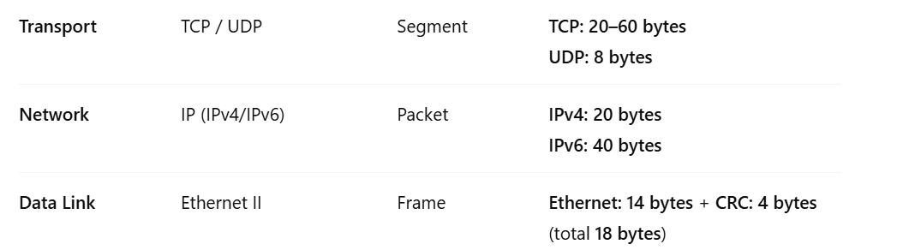

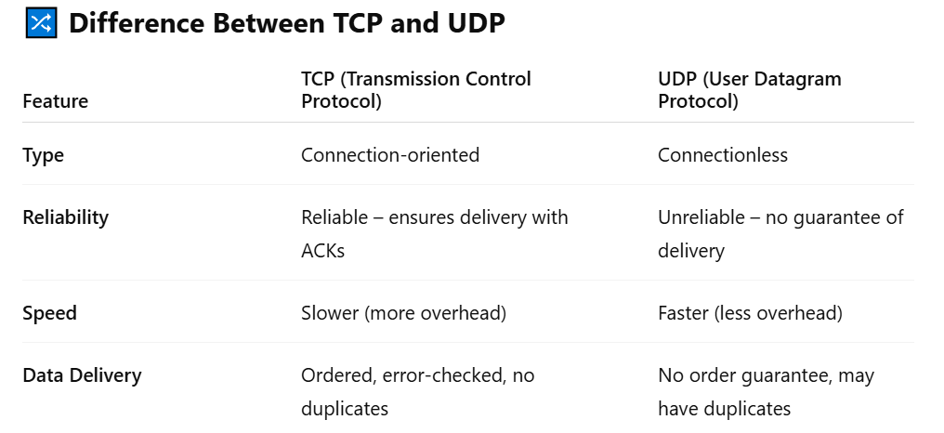
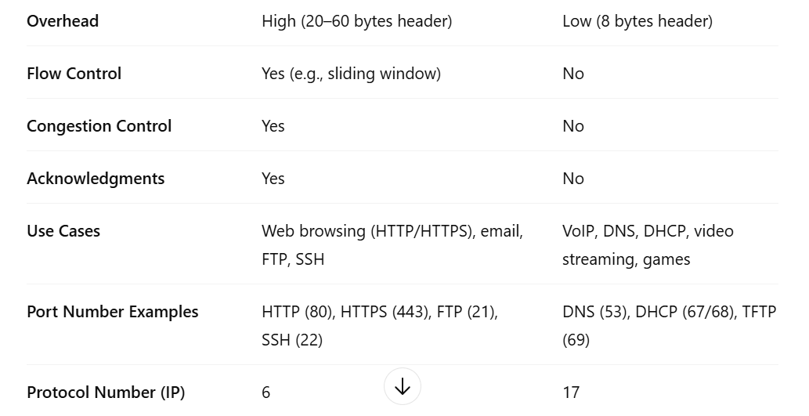

ICMP -1 The Internet Control Message Protocol is a supporting protocol in the Internet protocol suite. It is used by network devices, including routers, to send error messages and operational information .

Multiplexing and DE multiplexing

Different types of traffic is identified using different frequencies .FBD-TBD Frequency based division and Time based division
Data Traffic,Voice traffic,Verio traffic.

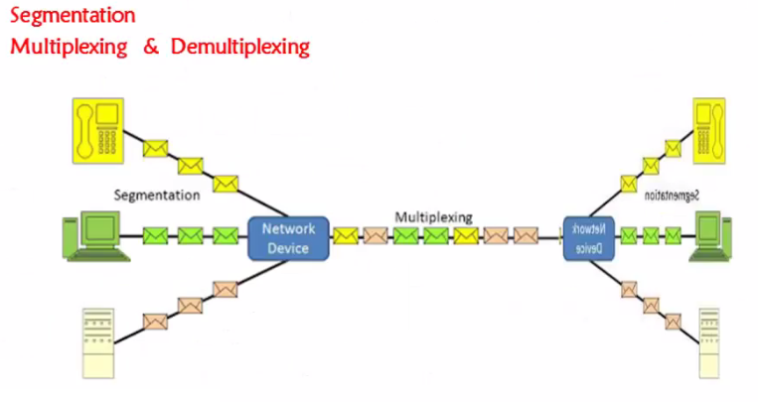
Sequencing and reassembling .

Hello how are you
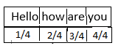
Flow control – To control the flow Sliding window protocol was found . I am sending data at 100 mbps speed but the other side he has capacity to receive only 10 mbps . sliding window protocol resolves this issue .

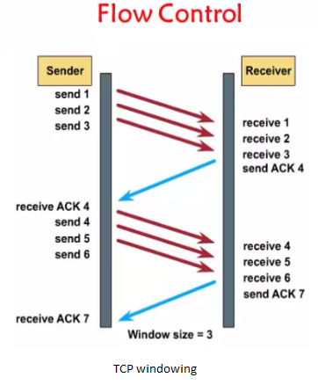

Network Layer

The Network Layer is the 3rd layer in the OSI (Open Systems Interconnection) model , It is responsible for
1.Logical addressing – IP address
2.Path determination - Routing
These are the two major functionalities of NL.

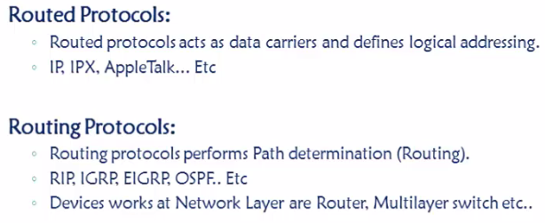

DATA layer
The Data Layer is the 6th layer in the OSI (Open Systems Interconnection) model . It is responsible for “End to end delivery of data between the devices under a LAN network”
2 main functionalities.

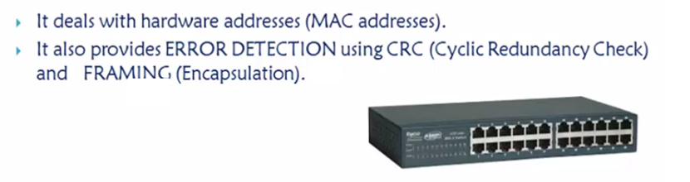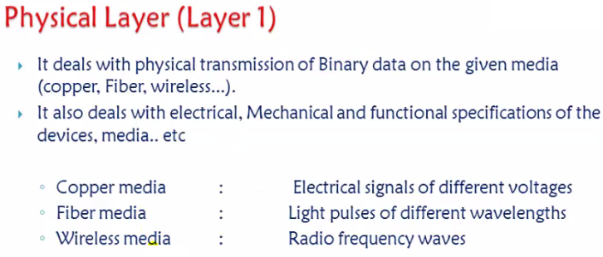

TCP / IP Model
TCP/IP Model was developed and proposed by ARPA (Advanced Research Projects Agency), This model was mainly created to connect military Network.

Main goal of TCP / IP model
1.How to transmit data across the network
2.How to format the data so that the other side understands it .

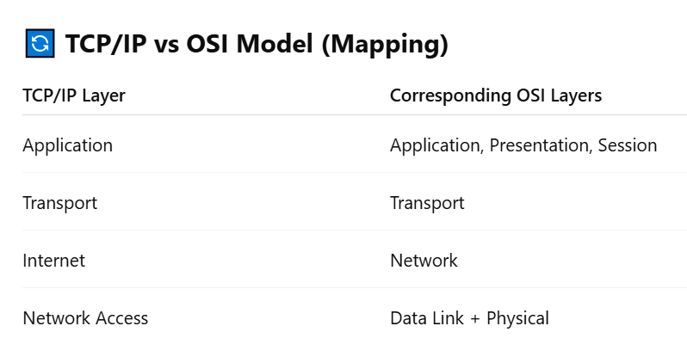
NOTE: Extra not in syllabus.
Difference between KBps and Kbps (Kilo bytes/sec and Kilo bits/sec)
Measure of file size: KBps
File size i.e. how big the file or how much space a file occupies in the hard disk measured in terms of Kilo Bytes (KB upper case “K” and upper case “B”). In computing terms the upper case “K” stands for 1024. 1024 is computed from 210. (2 power 10). 2 denote the number of characters in the binary system which is used to store data in the disc (ones and zeroes).
Other abbreviations like mega, giga and terra also use the base as 1024,
1KB (Kilo Byte) = 1024 Bytes (approximately 1000 Bytes)
1MB (Mega Byte) = 1024 KB (approximately 1000 Kilo Bytes or 1 million Bytes)
1GB (Gigabyte) = 1024 MB (approximately 1000 Mega Bytes or 1 billion Bytes)
1TB (Terra Byte) = 1024 GB (approximately 1000 Gigabytes or 1 trillion Bytes)
Measure of data transfer speeds: kbps
Data transfer speed over the networks (including the internet) is calculated in terms of bits per second: kilobits (kb small case “k” and small case “b”). The higher the kbps i.e. more the bits transferred per second, more the speed, faster the network/connection. Here k stands for 1000 (103 )
1 kbps (kilo bits per second) = 1000 bits per second
1 Mbps (mega bits per second) = 1000 kilo bits per second.
1 Gbps (giga bits per second) = 1,000 mega bits per second.
ISP bandwidth and download speeds
The most common confusion caused by the similarity of KBps and kbps is when it comes to internet bandwidth and download speeds. People often complain that their ISP promised 512kbps connectivity but they are seldom able to download any file at 512 KBps. They fail to notice the difference in cases of the units and hence think their ISP is cheating them or offering them poor quality service. As mentioned earlier data transfer speeds are always calculated in terms of kilo bits per second (kbps) so an ISP connectivity of 512 kbps promises of transfer of at the max 512 kilo bits per second.
On the other hand, file size measure is always in Kilo Bytes and thus download speeds are always calculated based on how many Bytes per second are downloaded and hence Kilo Bytes per second (KBps). KBps and kbps are not interchangeable.
So an internet connectivity of say 512kbps can never achieve a download speed of 512 KBps. To calculate the maximum download speed of a “X kbps” connection, we need to use a simple formula as below.
Download KBPS speed = (Kbps value*1000) /8)) / 1024.
I.e. For a connectivity of 512 kbps
kbps value * 1000 = 512 * 1000 = 512000
512000 / 8 = 64000
64000 / 1024 = 62.5 KBps
Therefore theoretically an internet connection of 512kbps bandwidth can download at a speed of 62.5 KBps.
If you don’t want to go through all the hassles of the above formula, just multiply the kbps value with 0.1220703125 to get the KBps value.
512 kbps * 0.1220703125 = 62.5 KBps. Simple!
Internet connectivity
Download speed (approx) ( Marked in Italics)
256 kbps - 31.3 KBps
384 kbps - 46.9 KBps
512 kbps - 62.5 KBps
768 kbps - 93.8 KBps
1 mbps ~ 1000kbps - 122.1 KBps
I have mentioned download speed as approximate because they will vary (always reduce) by 15 – 20% due to network signal loss, computer hardware overheads etc. So for realistic, real world figures always reduce 15 – 20% from the computed KBPS download speeds
Now I guess the confusion of kbps and KBps has cleared away. Just remember when you talk in terms of network it’s always bites per second (bps) and when you talk in terms of storage and files its always Bytes per second (Bps). And next time you won’t complain when your 512 kbps connection does not give you download speeds of 512KBps because now you know why .

Network Addressing Scheme
Binary : 0 and 1
Decimal : 0 1 2 3 4 5 6 7 8 9
Hexa decimal : 0 1 2 3 4 5 6 7 8 9 10 [A] , 11[B] , 12 [C] , 13[C] , 14 [D], 15[E] .

Types of various Units of Memory-
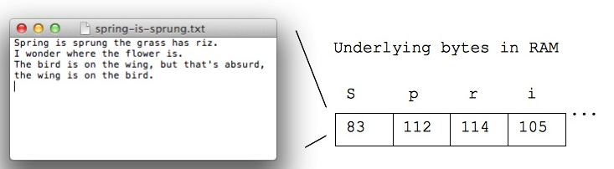

- Bit – 0 1
- Byte – 8 bits
- Kilo Byte – 1024 bytes
- Mega Byte - 1024 KB
- Giga Byte - 1024 MB
- Tera Byte – 1024 GB
- Peta Byte
- Exa Byte
- Zetta Byte
- Yotta Byte

DATA REPRESENTATION FORMATS

Binary - Binary is used for calculating network masks
Decimal - Decimal is the human numbering system we display IPv4 addresses
Hexa decimal - hexadecimal is used to display Ethernet MAC addresses and IPv6 addresses

So expertize in converting of all these is very much required .

BINARY TO DECIMAL
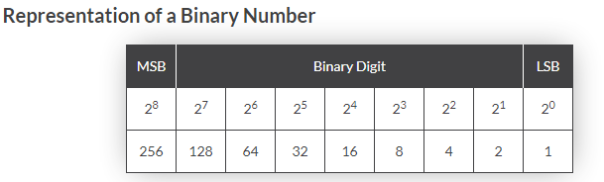

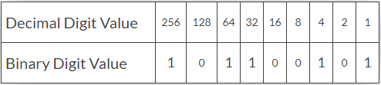

DECIMAL TO BINARY
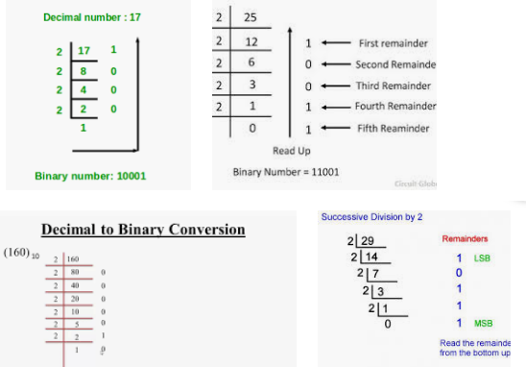
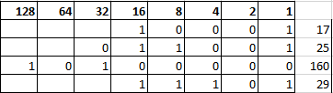
Convert hex to binary and decimal
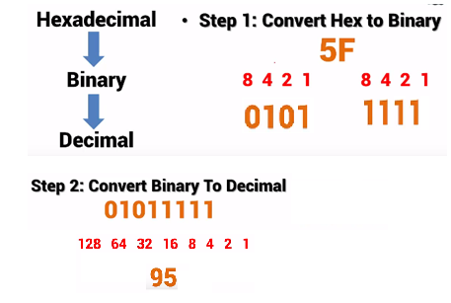
********************END OF CONVERSION****************

IP addresses

IP address is a logical address, It is a 32 bit binary number represented in decimal format.It is used to represent devices in a network to send and receive data between two devices.

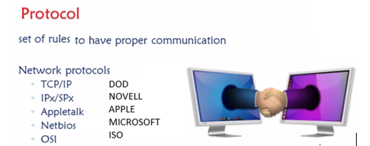

If I want to access or communicate any one through internet then it has to support tcp / ip protocol.
Inside the tcp / ip it has its own addressing of every device which we call it as IP ADDRESS.
When it comes to addressing there are two types of addresses
1.MAC address – Physical address.
2.IP address – Logical address.

- Mac address : A media access control address (MAC address) of a device is a unique identifier assigned to a network interface controller
It is a 48 bit binary number represented in hexa decimal format .
Mac / physical / Hardware / Burnt in address .

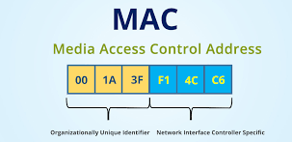

2.IP ADDRESS : IP addresses are 32 bit binary number represented in decimal format . AND DIVIDED in to 4 octet s .
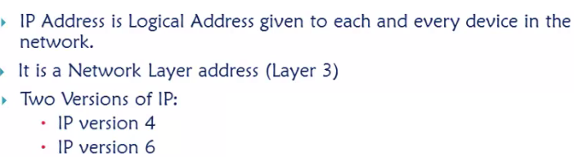
IP Address = 2 raise 32 ip address = 32billion – internet grew shortage IP address , To overcome the shortage of IPV4 , IPv6 128 bit

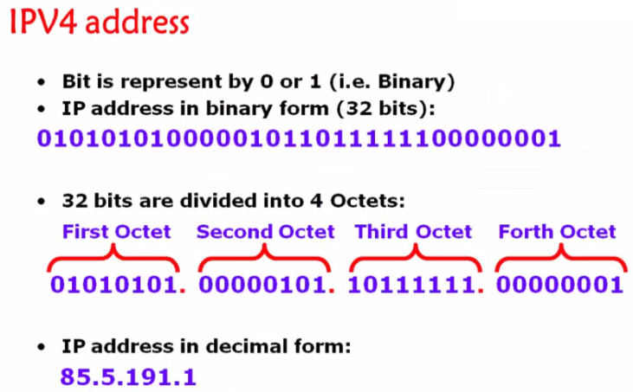

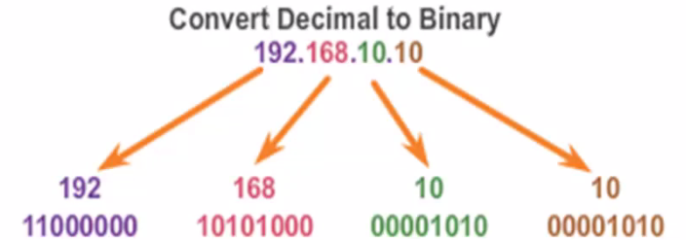

How to give IP address manually in your PC
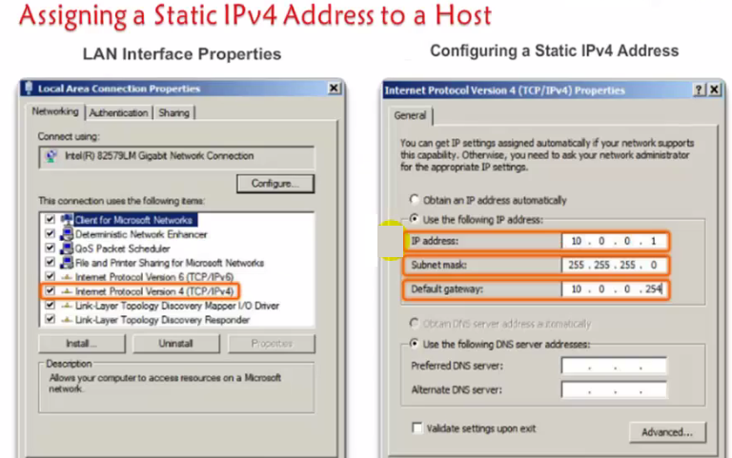

Control panel , Network and sharing . In real time – DHCP
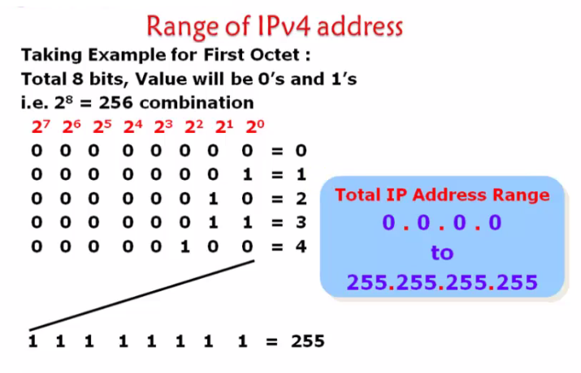
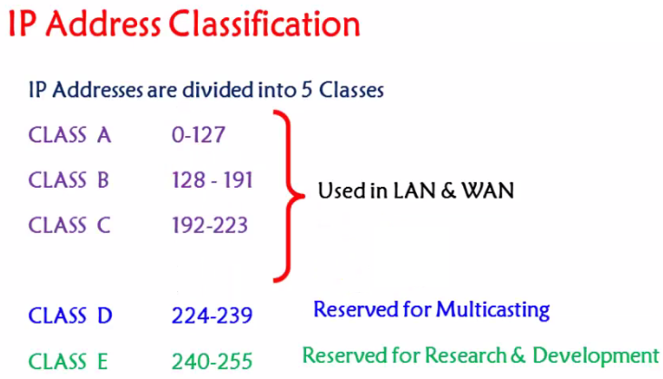
169.254.0.0 to 169.254.255.255 – APIPA Ip addresses .
Unicast , Multicast and broadcast .

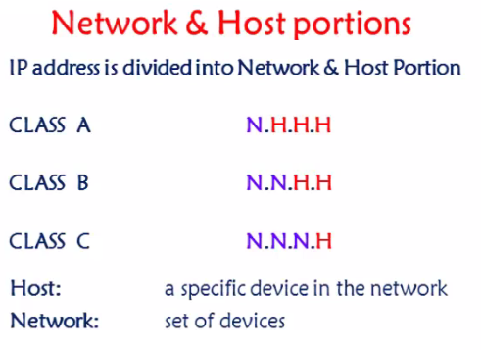

If two devices has to communicate then network part should be same .

256 IP addresses
256 raise 2 = 65536
256 raise 3 = 16777212

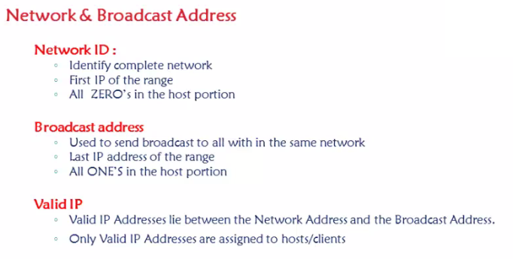
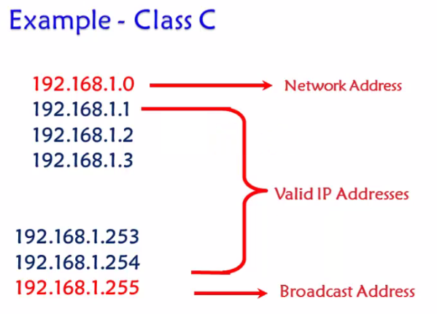

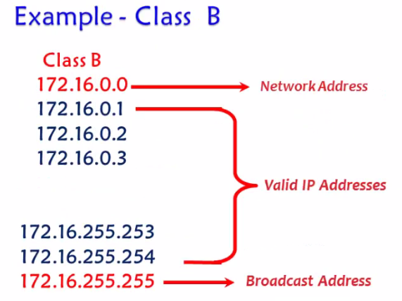
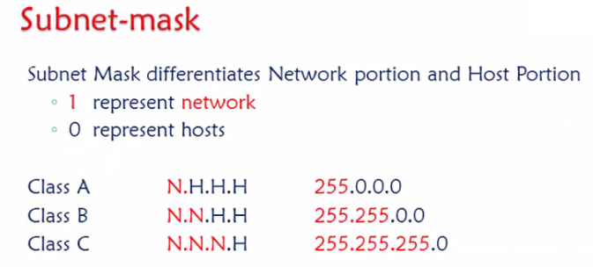

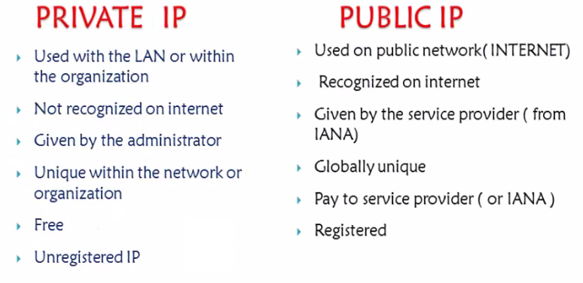

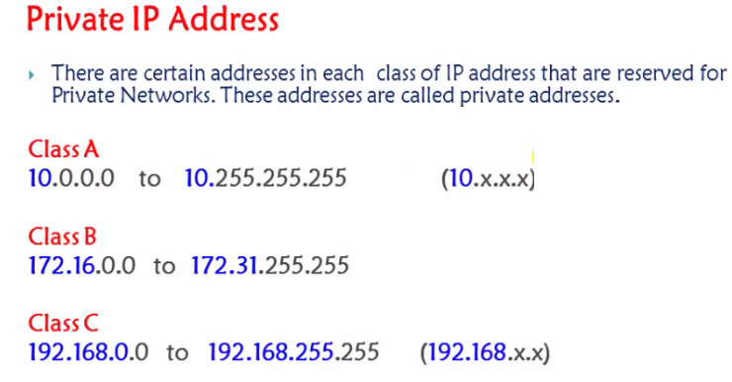

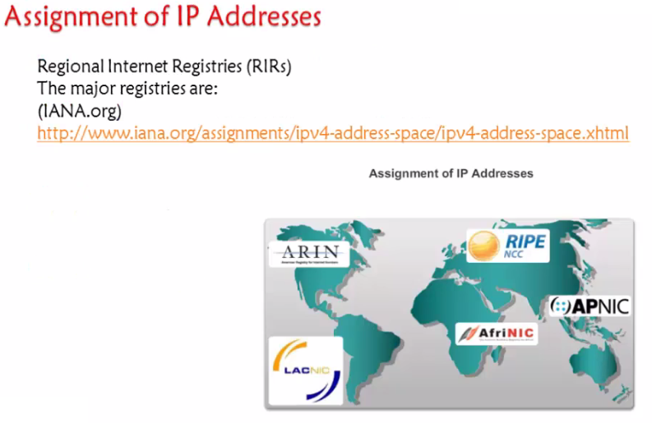
https://www.iana.org/
https://www.iana.org/assignments/ipv4-address-space/ipv4-address-space.xhtml

Subnetting

A subnetting, or sub networking, is the process of splitting a single large network into two or more strands. This means that an otherwise mammoth network can be subdivided into smaller, more localized networks

Subnetting benefits.
- Efficient IP address Utilization
- Ease administration
- Better network performance
- Simplifies Troubleshooting and management.

1.Network Scenario 1
216.21.5.0 – 5 Networks

1.Determine the number of NETWORKS and convert them to bits
128 64 32 16 8 4 2 1
0 0 0 0 0 1 0 1 - 00000111

2.REVERSE the bits (Entire host part) in subnet mask and find the INCREMENT

255.255.255.0
11111111.11111111.11111111.11100000
32
So the subnetworks subnet mask will be 255.255.255.224

3.Using the increment – find the SUBNETWORKS
216.21.5.0 - 216.21.5.31 – 1st Subnetwork
216.21.5.32 - 216.21.5.63 – 2nd Subnetwork
216.21.5.64 - 216.21.5.95 – 3rd Subnetwork
216.21.5.96 - 216.21.5.128 – 4th Subnetwork
216.21.5.128 - 216.21.5.159 – 5th Subnetwork
216.21.5.160 - 216.21.5.191 – 6th Subnetwork
216.21.5.192 - 216.21.5.223 – 7th Subnetwork
216.21.5.224 - 216.21.5.255 – 8th Subnetwork

Even though the required networks are 5 you will get 8 only.
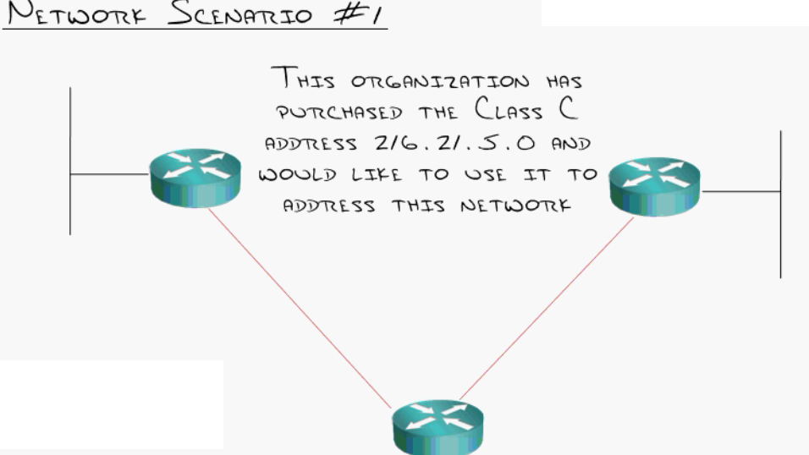
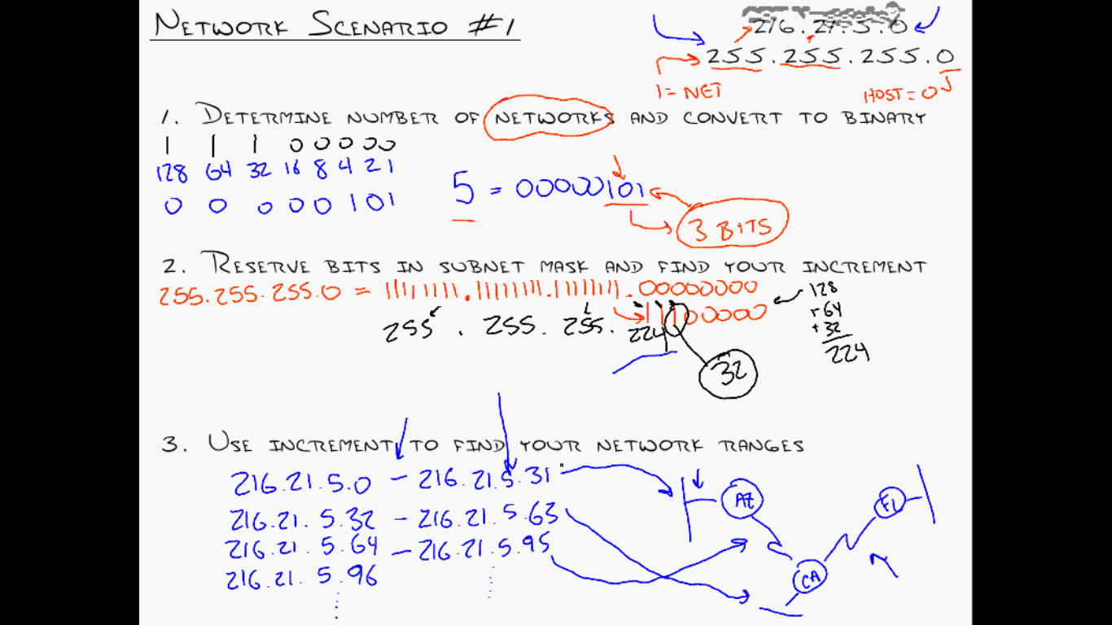

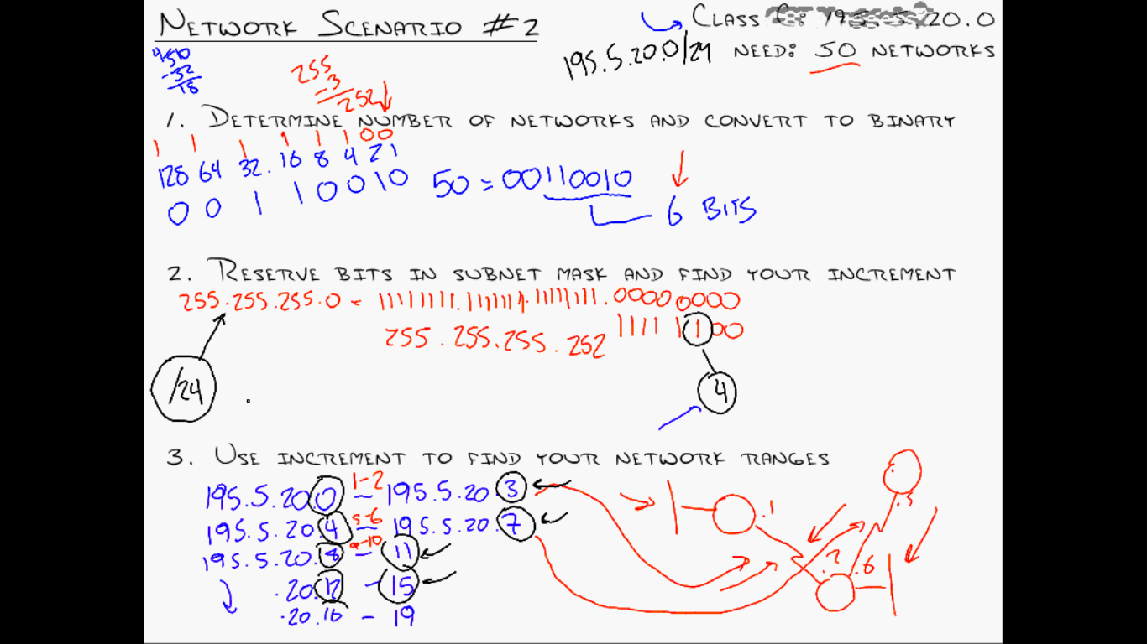
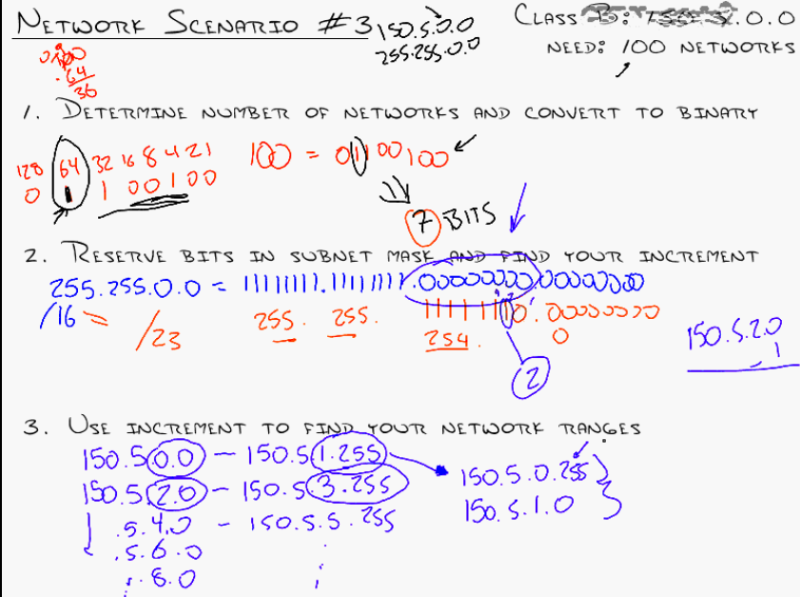

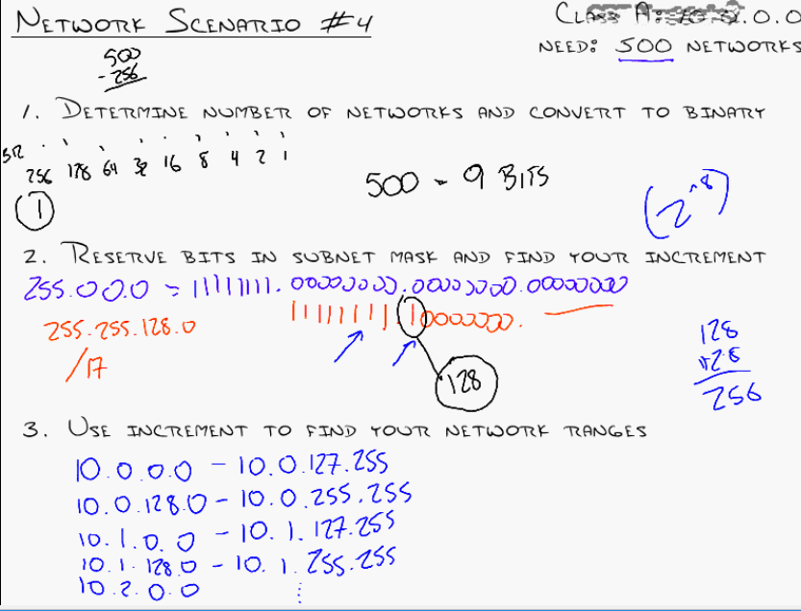

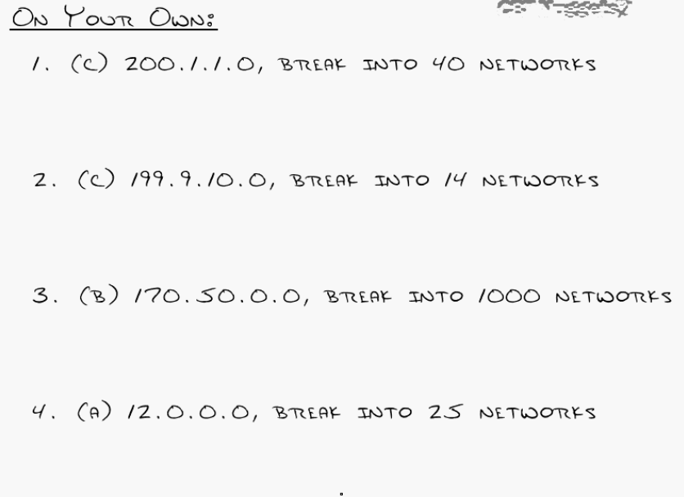
SUBNETTING BASED ON HOSTS

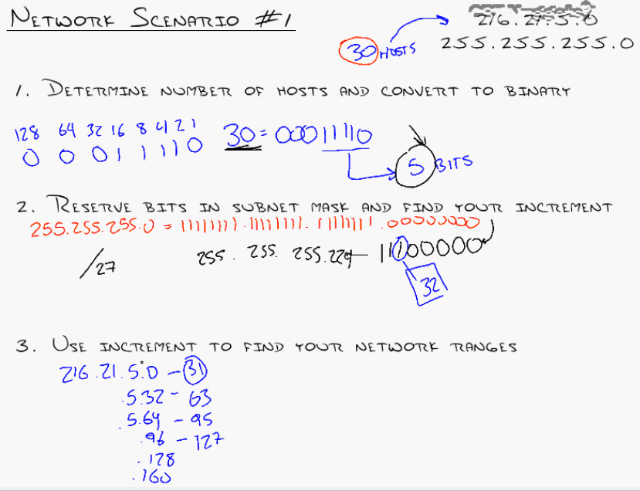
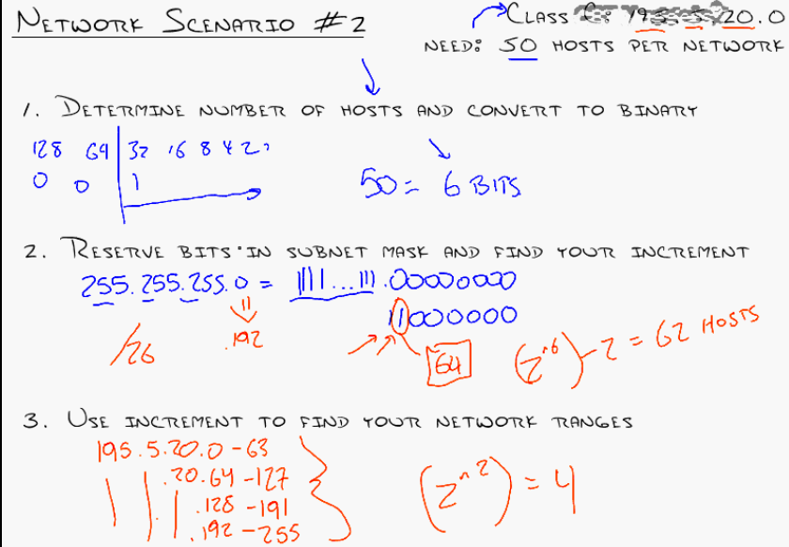

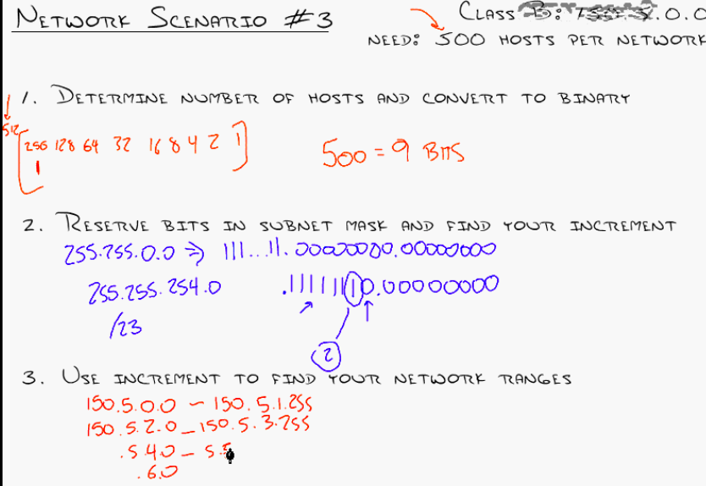
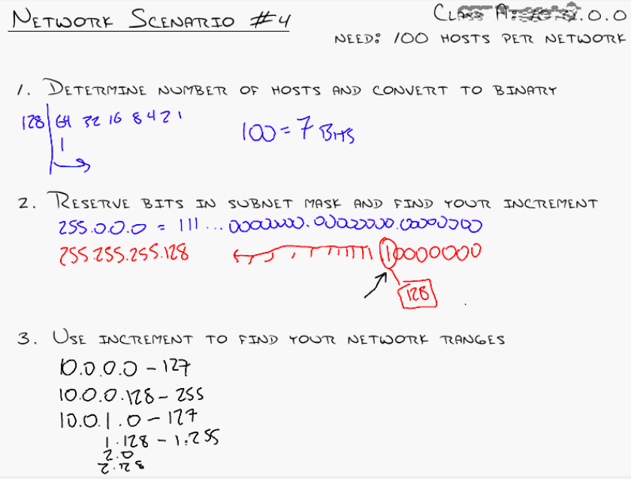
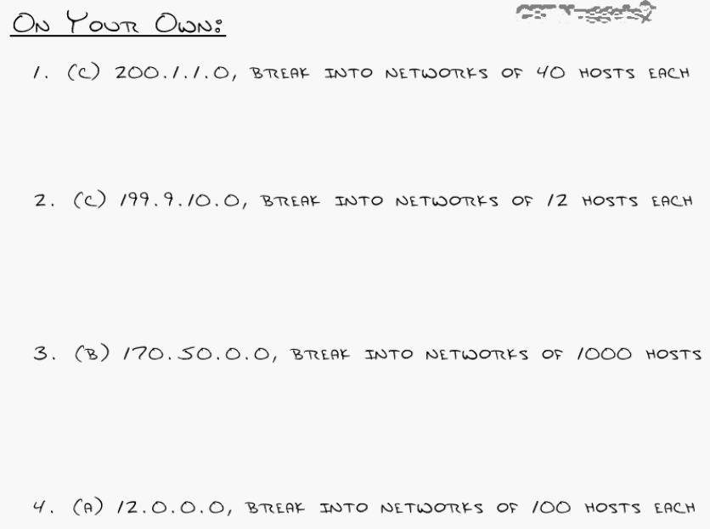

VLSM

Very important as it is used in real time
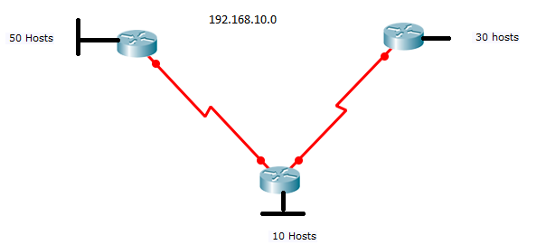

Finds lots of Sub netting Questions here:

http://www.subnettingquestions.com/
Question: What valid host range is the IP address172.18.229.223 255.255.255.128 a part of?
Answer: 172.18.229.129 through to 172.18.229.254
Question: What is the last valid host on the subnetwork 172.24.52.0 255.255.255.0?
Answer: 172.24.52.254

Supernetting – will discuss after Routing.

“What is Discontiguous vs. Contiguous?

Contiguous vs. Discontiguous Networks (in networking)
This concept is mainly relevant to IP subnetting and routing,

Contiguous Network
- Definition: All subnets of a network are logically connected and fall under the same major network (classful network).
- Example:

192.168.1.0/24
192.168.2.0/24
192.168.3.0/24
All are part of 192.168.0.0/16 – Contiguous.

Discontiguous Network
- Definition: Subnets belong to the same major network but are separated by a different network – break in logical continuity.
- Example:
Network A: 192.168.1.0/24
Network B: 10.0.0.0/8
Network C: 192.168.2.0/24
Here, Network A and C are from the same classful network (192.168.0.0/16), but separated by an unrelated 10.0.0.0 network – this is Discontiguous.
”
What is Major Network Number?

🔑 Major Network Number (also known as Classful Network Number)
In traditional classful addressing, a major network number refers to the original base network address defined by IP address classes (A, B, or C), before subnetting was introduced.

🧱 Classful IP Addressing Basics
Class | Starting Bits | Default Subnet Mask | Address Range | Major Network Example
A | 0 | 255.0.0.0 (/8) | 1.0.0.0 to 126.0.0.0 | 10.0.0.0
B | 10 | 255.255.0.0 (/16) | 128.0.0.0 to 191.255.0.0 | 172.16.0.0
C | 110 | 255.255.255.0 (/24) | 192.0.0.0 to 223.255.255.0 | 192.168.1.0
- The major network number is the address defined before any subnetting is done.
- For example:
  - 192.168.1.0/24 → Major network is 192.168.1.0 (Class C)
  - 10.1.1.0/24 → Major network is 10.0.0.0 (Class A)
”

Assigning IP address to a small network .

